**Parts Catalog**

**Documentation**



|  |  |
| --- | --- |
| Application: | eServices |
| Module: | Parts Catalog |
| Analyst Name: | Thomas Johns |

#### Revision History

|  |  |  |
| --- | --- | --- |
| **Revision Level** | **Revision Date** | **Revision Description** |
| 1 |  | Original Draft |

#### Table of Contents

1.0 Overview of the Parts Catalog Module 4

1.1 Process Flow 4

1.2 What is a Parts catalog? 6

1.3 Locations and Sections 6

1.4 What is a Parts Bulletin? 7

1.5 What is a Standard list? 7

1.6 What is a Locolist? 8

1.7 What role does parts catalog play in eServices? 8

1.8 What role does parts catalog play outside of eServices? 8

2.0 Standard List (STD LIST) Creation Process 8

2.1 Standard List Overview 8

2.2 Creating a Standard List 8

2.3 Maintaining a Standard List 9

3.0 Parts Bulletin (PB) Creation Process 10

3.1 Parts Bulletin Overview 10

3.2 Creating a PB 10

3.3 Maintaining a PB 11

4.0 Parts Catalog (GEX) Creation Process 12

4.1 GEX Overview 12

4.2 Creating a GEX 13

4.3 Maintaining a GEX 15

5.0 The eServices Search & Searching Parts Catalog 15

5.1 eServices Search Overview 15

5.2 eParts Catalog Overview 15

5.3 Doing an eParts Catalog Search 15

5.4 Ordering Parts from eParts Catalog in eServices 18

6.0 Roles and Responsibilities 19

6.1 Parts Catalog Administration roles 19

6.2 Responsibilities with access to view a parts catalog 19

6.3 Responsibilities with access to order from parts catalog 19

6.4 Other 19

7.0 Other Common Questions about Parts catalog 20

7.1 Where do the PDF drawings come from that are in the parts bulletins when a search is done from the home page? 20

7.2 How does one know if a locomotive has a parts catalog? 20

7.3 What is the difference between Part Number on the GETS_LMS_LOCOMOTIVE_ALL table and Locolist Name on a Parts Catalog? 21

8.0 Technical Details 21

8.1 Database Tables (Including but not limited to) 21

8.2 Supporting Technical Documentation 22

9.0 Appendix/Supporting Documentation 22

9.1 Additional Documentation 22

9.2 Definitions: 22

9.3 Related Modules 23

9.4 Contact Information 23

#### NOTICE

The information contained in this document is neither to be used for other than the purposes for which this document is furnished by the General Electric Company, nor is this document (in whole or in part) to be reproduced or furnished to third parties or made public without the prior express written permission of the General Electric Company.

# Overview of the Parts Catalog Module

## Process Flow

**A simple view of parts catalog’s process flow from start to end:**

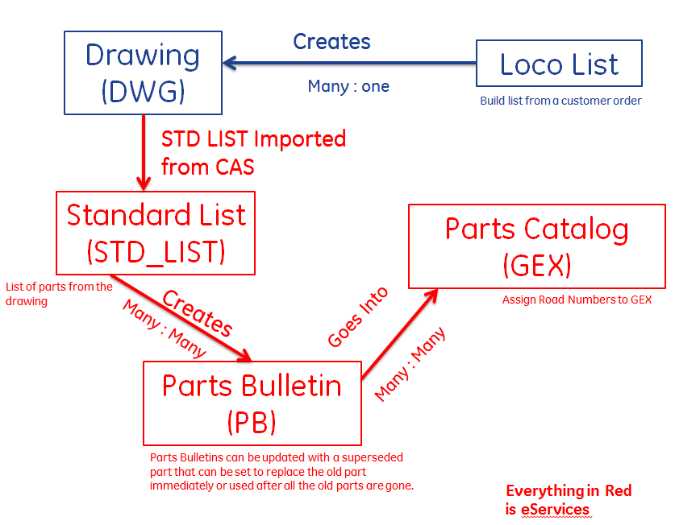

**Explanation:**

* One Loco-list creates several drawings
* A drawing creates a standard list
* One or more standard lists create a part bulletin
* Several parts bulletins go into the creation of a parts catalog.

The above version is a simplified version of the actual process flow for understanding.

**A more realistic version of parts catalog’s process flow would be:**

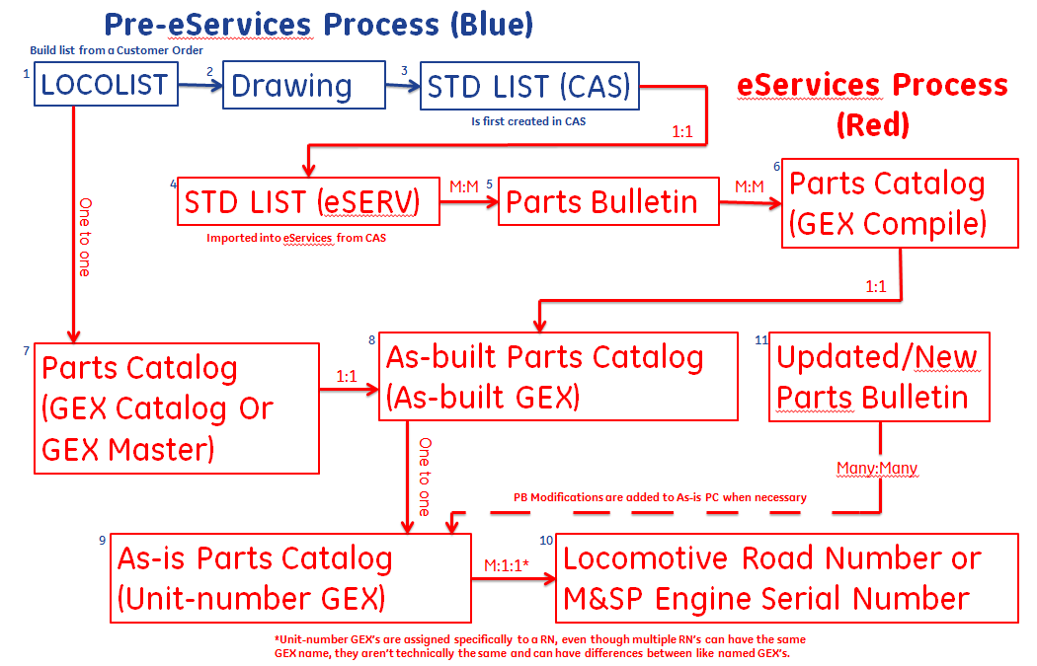

**Explanation:**

1. A Loco-list is created by business leaders
2. Loco-list is used to create several drawings of part assemblies
3. A list of parts from a drawing is used to create a standard list (STD LIST) in CAS
4. A standard list is imported from CAS into eServices.
5. One or more STD LIST’s go into a parts bulletin
6. Several Parts Bulletins are assigned to a GEX Compile
7. A GEX Master is created and is assigned the appropriate Loco-list
8. A GEX Compile is assigned to a GEX Master; the GEX Master officially becomes the AS-built Parts catalog at this stage.
9. An As-built Parts catalog is assigned to a locomotive & becomes a Unit-number GEX; but the As-built remains unassigned afterwards.
10. The Unit-number is a running total of what makes up a specific locomotive. Other Road numbers may have the “same” named Unit-number GEX, but these aren’t necessarily the same, because they’re assigned to specific road numbers. Meaning if BNSF-5 & BNSF-6 both have GEX-10000-01 for a parts catalog, I can add a new PB to BNSF-5 without changing BNSF-6’s GEX & vice-versa.
11. Updated or New PBs are continuously added/removed/changed to an As-is.

The more complex version is also attached as a PowerPoint in 9.1 for easy viewing.

**Attached below is Documentations Center’s actual process flow as documented by Gary Dudenhoefer:**



## What is a Parts catalog?

Specifically, a parts catalog is a list of tabs & locations that make up a locomotive or a Marine & Stationary Power Engine. Within these tabs are parts bulletins; within a parts bulletin is a list of parts that make each one. A simple comparison for a parts catalog would be a bill of materials.

Documentation center refers to parts catalogs as G.E.X.’s and there are three types of these in eServices. First off there is the As-built GEX; the As-built is the list of parts bulletins that went into the manufacturing of a specific locomotive or a set of locomotives. Secondly there is the Unit-number GEX, this can be put more simply as the As-is GEX. The As-is is the list of parts bulletins that are currently documented for that specific locomotive. These first two are the main types. The third is a GEX compile. A GEX compile is created first before the other two can be created as per the parts catalog process flow.

**NOTE:** Within the eServices database the two main types of GEX’s are within the GETS_PC_CATALOG table, however the third type exists within the GETS_PC_GEX_COMPILE table.

## Locations and Sections

Within a parts catalog there are locations that make up a locomotive. Within these locations are sections. Listed below are the locations and their corresponding sections:

|  |  |
| --- | --- |
| ***Location Name*** | ***Section Name*** |
| Aux Cab | AUXILIARY CAB |
| Aux Cab | MISCELLANEOUS CONTROL EQUIPMENT |
| Common Equipment | GENERAL PURPOSE HARDWARE |
| Engine | ENGINE CAB |
| Engine | ENGINE CONTROL GOVERNOR |
| Engine | FORWARD END COVER |
| Engine | FUEL LINKAGE AND GOVERNOR DRIVE |
| Engine | FUEL OIL, LUBE OIL PIPING |
| Engine | MAIN FRAME |
| Engine | MAJOR ENGINE ASSEMBLIES |
| Engine | MANIFOLD |
| Engine | POWER ASSEMBLY |
| Engine | POWER PLANT MOUNTING |
| Engine | TURBOCHARGER AND INTERCOOLER |
| Nose Cab | NOSE CAB |
| Operator Cab | CAB HEATER / AIR COND / WATER COOLER |
| Operator Cab | OPERATOR CAB |
| Platform | PLATFORM |
| Rad Cab | AIR BRAKE |
| Rad Cab | RADIATOR CAB |
| Traction Gen / Aux Power | TRACTION GENERATOR AND AUXILIARY POWER |
| Trucks | TRUCK |

Sections define where in the locomotive parts as assigned. Parts are assigned to sections through parts bulletins. Parts Bulletins are attached to these list of section names for each locomotive or Marine & Stationary Power engine. Each Section has its own tab id and part bulletins are assigned to at least one tab id.

## What is a Parts Bulletin?

A parts bulletin is a list of parts that make up an assembly within a locomotive. Parts bulletins are assigned to sections within a locomotive. Because parts bulletins are assemblies they can be made up of other parts bulletins; these are called associated parts bulletins and are tied to a part number.

Parts bulletins are created from standard lists and can be made up of many.

## What is a Standard list?

A standard list is imported through CAS (another GE application) into eServices; it is like the raw version of a parts bulletin. Standard lists go into the creation of parts bulletins and are another list of parts.

Standard lists are created from technical drawings in CAS. These technical drawings are based off the specification put forward from a locolist. Importing a standard list from CAS is documentation center’s starting point within eServices

## What is a Locolist?

A Locolist is the starting point for documentation center in general and is created outside of eServices. A Locolist is the part number which is assigned to a locomotive or a Marine Engine. Documentation center refers to the Locolist as the list of specifications for a parts catalog. Doc center uses this list throughout the process of creating the documentation within eServices. Doc center makes a tie to the Locolist while creating a GEX Asbuilt in the GEX master page in eServices.

## What role does parts catalog play in eServices?

The part lists that documentation center create within eServices affect pages such as the materials shopping cart and the eServices Search on the home page.

## What role does parts catalog play outside of eServices?

Parts catalog is also tied to the Customer Web Center & the List Configurator Applcation. GE Transportation customers can view parts catalogs for specific locomotives for not only themselves but for customers of their own as distributors. CWC redirects them to an eServices page that is something similar to the eParts Catalog Search on our home page.

CWC users can also order parts through parts catalog, similarly to the way material users do on eServices.

List Configurator is an application designed by the HIT Team to allow internal field users to search for Consumable Parts.

# Standard List (STD LIST) Creation Process

## Standard List Overview

A Standard List is made from a drawing and will contain one or more parts. A standard list can be created from a pre-existing standard list in eServices or is imported from CAS into eServices.

## Creating a Standard List

Creating a Standard List from either a pre-existing Standard list or from importing through CAS, can be done using the Create Standard List tab in the Catalog Home of Documentation Center:

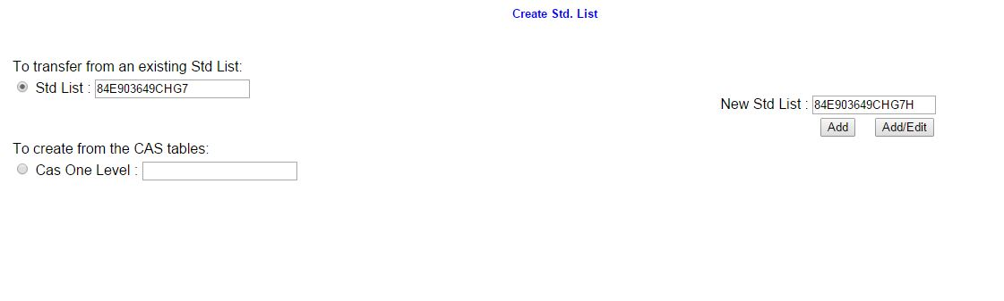

## Maintaining a Standard List

Editing a standard list can be done using the Edit Standard List Tab in Catalog Home:

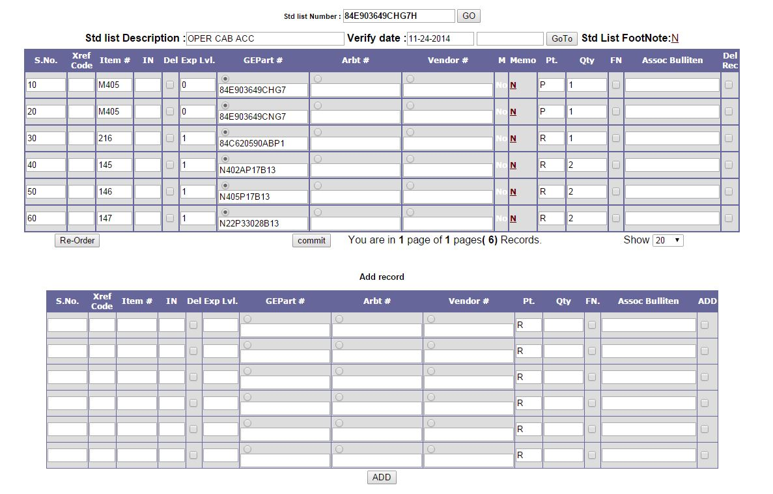

Deleting a Standard List can be done from the Delete Standard list tab in Catalog Home:

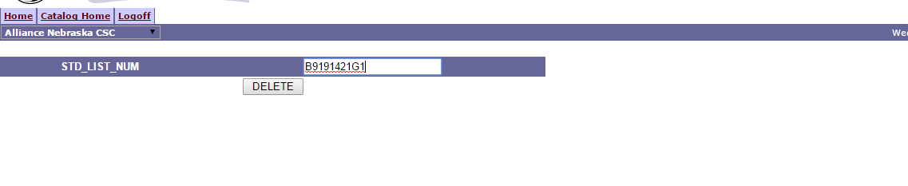

# Parts Bulletin (PB) Creation Process

## Parts Bulletin Overview

A Parts Bulletin is made from one or more Standard Lists.

## Creating a PB

First step is to create a new PB record in which to build off of.

This can be done from the New PB Name tab in the Catalog Home of Documentation Center:

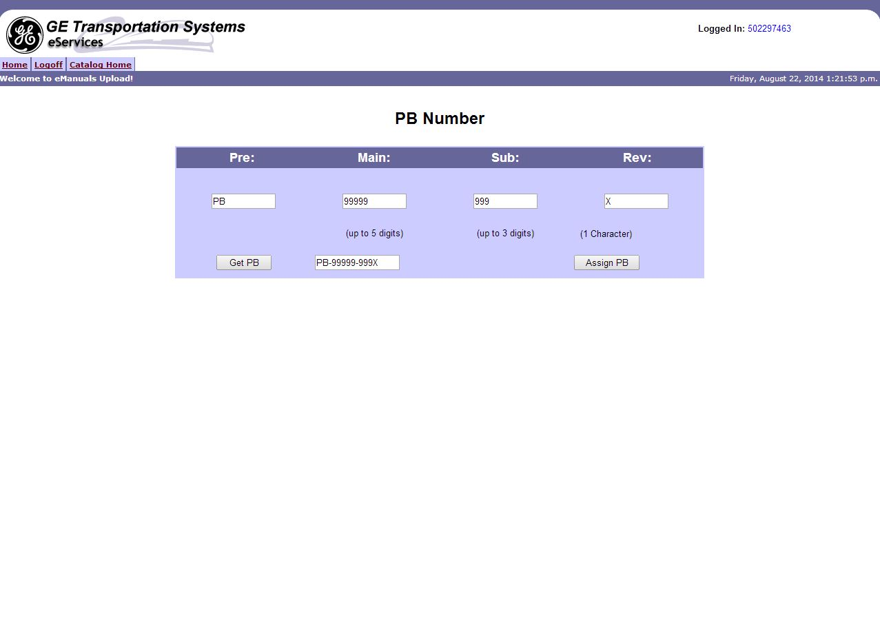

The second step is to assign the standard list(s) to the parts bulletin.

This can be done from the Create PB from Std List(s) tab in Catalog Home:

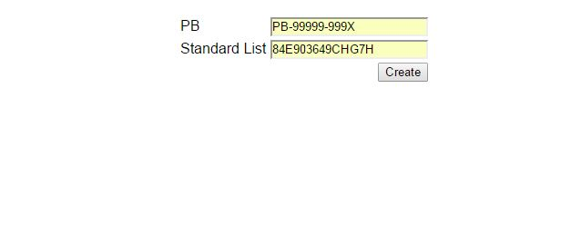

The third step is to Add or remove any parts as needed and then Publish.

This can be done from the Edit PB and Submit to Material Planner tab in Catalog Home:

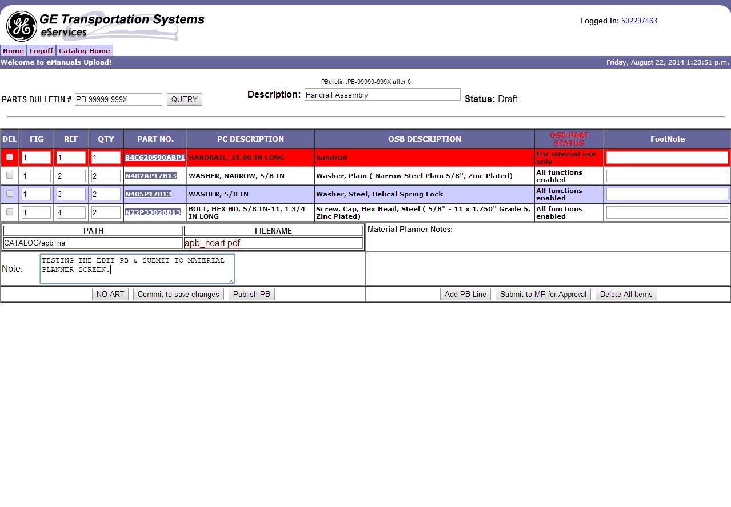

Publishing can also be done from the Unpublish / Publish PB tab in Catalog Home:

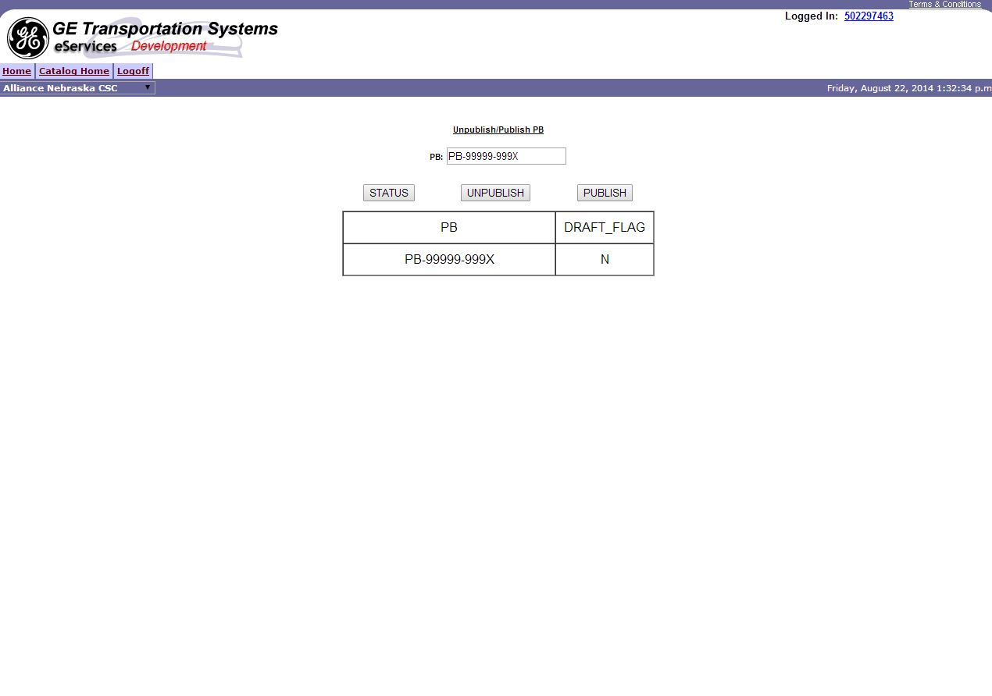

## Maintaining a PB

Parts Bulletins constantly need to have parts replaced or deleted.

This can be done using the Edit PB and Submit to Material Planner Tab in Catalog Home:



Sometimes when Editing a PB it won’t let you edit a Published PB and it must be Un-published to continue.

This can be done from the Unpublish / Publish PB tab in Catalog Home:



# Parts Catalog (GEX) Creation Process

## GEX Overview

A GEX is made up of several Parts Bulletins. After Assigning parts bulletins to a GEX Compile, the GEX Catalog is created. Afterwards the GEX Compile is assigned to the GEX Catalog. At this point in the process the GEX Catalog is more specifically known as the GEX Asbuilt and will contain the parts that went into manufacturing as reference. After creating the GEX Asbuilt, it is then assigned to a road number or an array of road numbers on an individual basis. At this point the GEX Catalog assigned to the road number is known as the Unit-number and each road number (or serial number) will have a unique parts catalog id linking it to this.

## Creating a GEX

The first step is to “Compile” the GEX, by assigning parts bulletins to it. The parts bulletins are assigned on an individual basis and when the first one is assigned the GEX compile record is created. Any PB assigned after that will just be updating the record.

This is done at the Assign PB to GEX tab in the Documentation Center Catalog home (the GEX at this page does not have GEX in front): 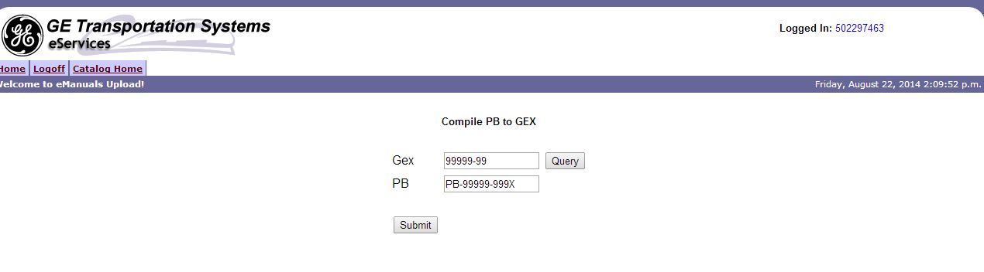

In addition on this page you can query a pre-existing GEX compile. Meaning that you can edit GEX Compiles from this screen as well.

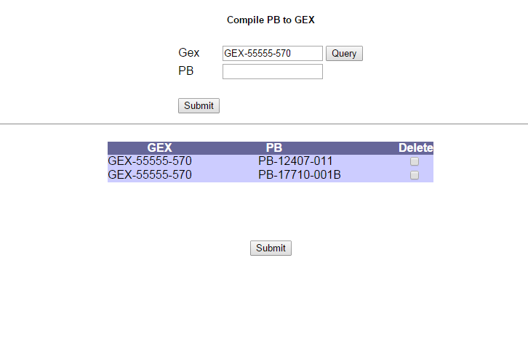

The second step is to create a record for the GEX Catalog to build off of. This is done in the GEX Master tab in Documentation Center’s Catalog Home. Typically at this page a Loco List number (which is a locomotive’s reference part number), a Parts Catalog Name (formatted with ‘GEX-‘ in front, then five numbers, then another hyphen, and then finally a couple more numbers [ex: GEX-12601-01]), a Publish Date (formatted in the typical oracle format for a date [ex: 01-JAN-2015]), and a requisition number.

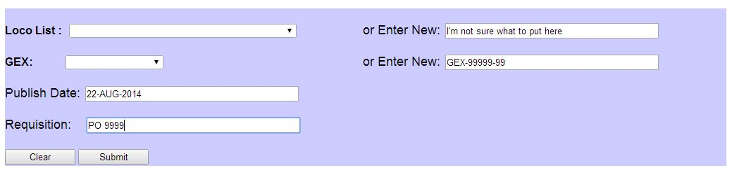

The third step is to assign the GEX Compile to the GEX Catalog (and thus assigning all the PB’s assigned to the Compile to the Catalog)

This can be done from the GEX Asbuilt tab in Catalog Home:

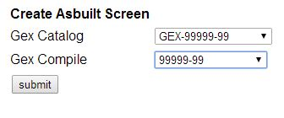

The fourth and final step to creating a parts catalog would be to assign it to road numbers.

This can be done from the Assign Road Number to GEX tab in Catalog Home:

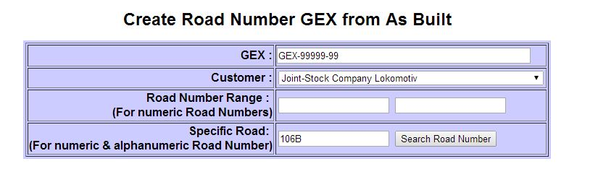

## Maintaining a GEX

Parts Bulletins are constantly changing and if existing ones are updated, the parts catalog will reflect that. However if the entire parts bulletin assembly is updated to something new, the parts catalog must reflect that change as well.

Maintaining a GEX can be done from the Update PB With Road Number screen in Catalog Home. At this screen, you can delete, remove, or add a PB to road numbers. You can have a range of numeric road numbers, look at a single Alpha-numeric road number with Specific Road No, or look at an entire customer’s road numbers with ALL RN (however this can only be done for Deleting or Replacing PB’s).

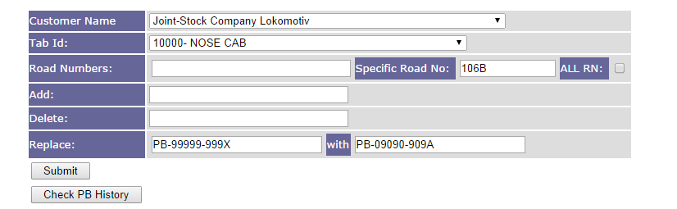

# The eServices Search & Searching Parts Catalog

## eServices Search Overview

eServices Search is on the front page of eServices & allows for searches to be done on parts catalog, schematics, & maintenance manuals. Searches are done by a specific customer’s road number. eServices Search is accessible by most, if not all, responsibilities with less privileged responsibilities are only able to search for road numbers under their designated customer.

## eParts Catalog Overview

eParts Catalog is the module that is visited when a search is done on “Parts Catalog” from the “eServices Search.” This module allows users to search for specific parts or to navigate to a specific parts bulletin within the parts catalog to view parts.

## Doing an eParts Catalog Search

A search begins with going to the Home page & locating the eServices Search under the message board:

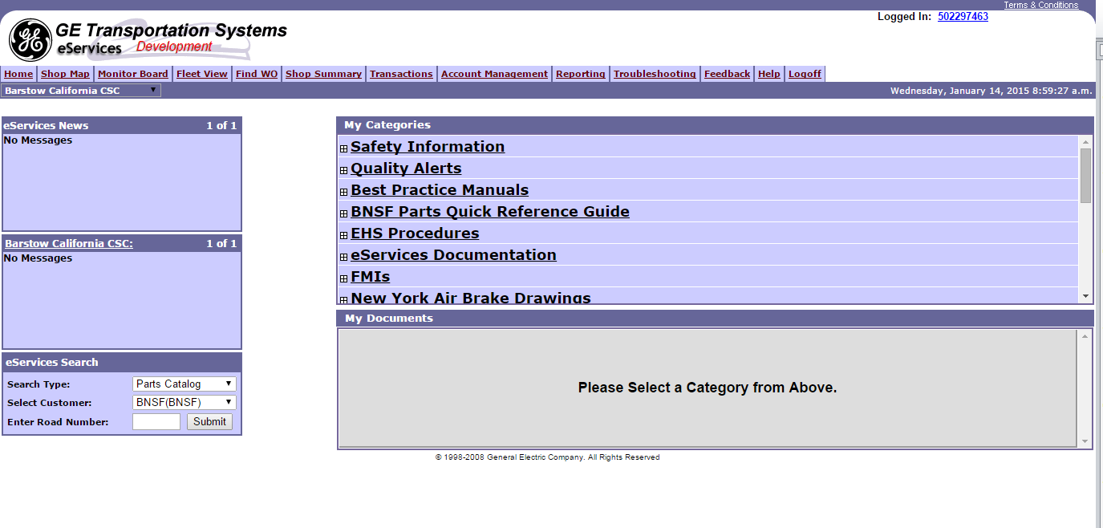

Next is to select a customer & then type in a road number, such as:

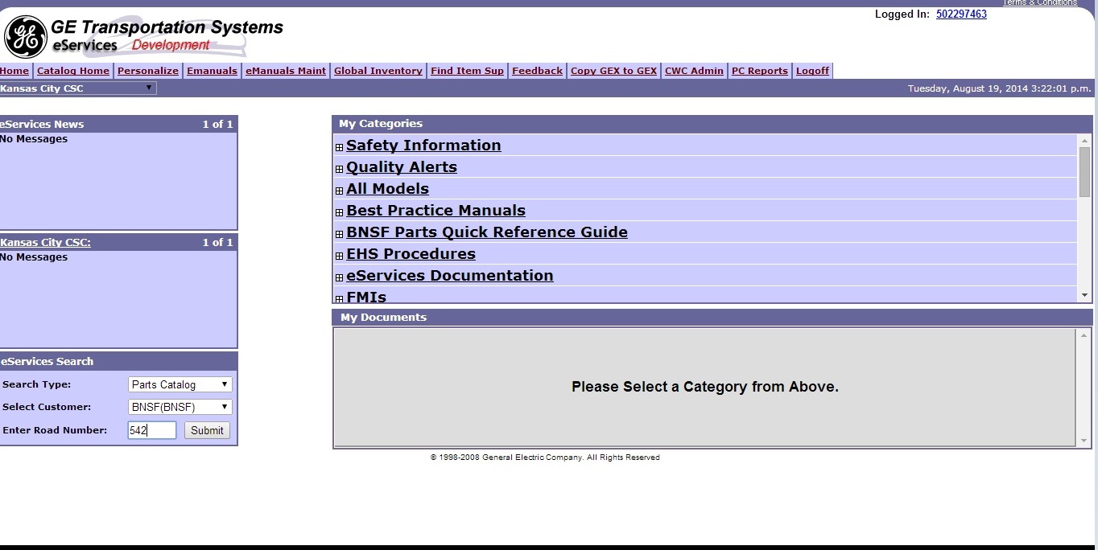

Clicking submit will take you to a page that looks like this:

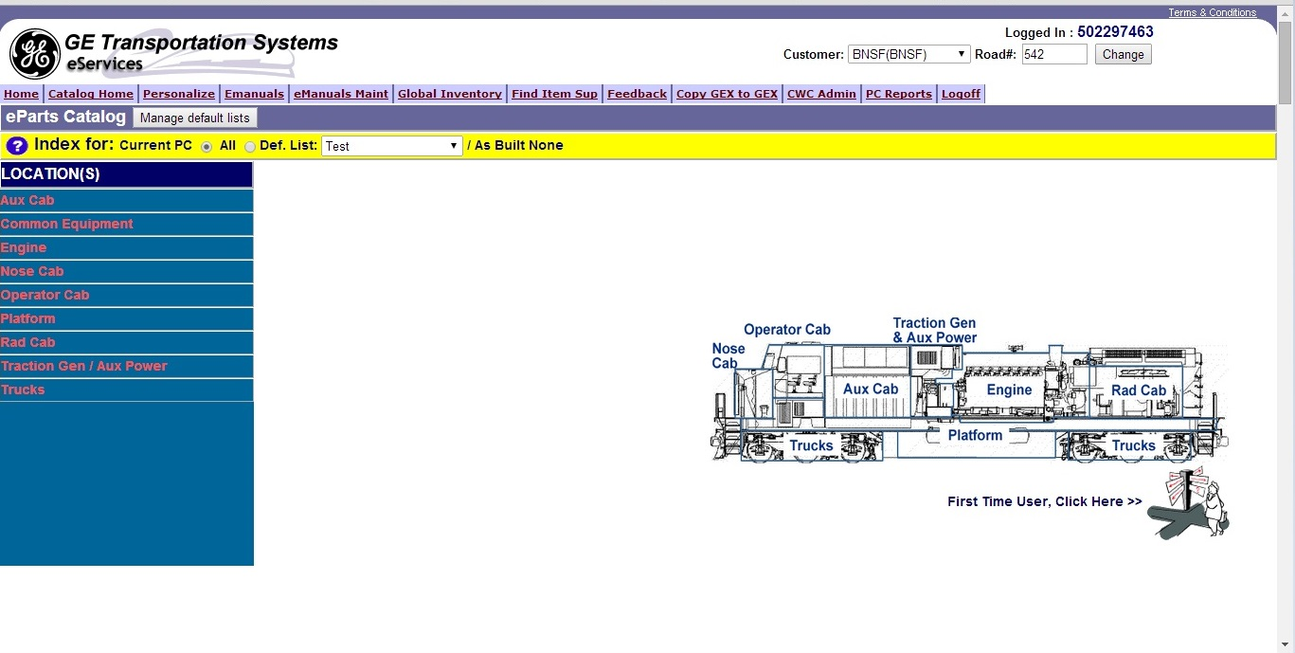

The locations that are listed on the left side of the page are the same as though that were mentioned in 1.3 of this document. Within the locations are the sections that were also mentioned in 1.3. Clicking through these will give you an appropriate list of PB’s.

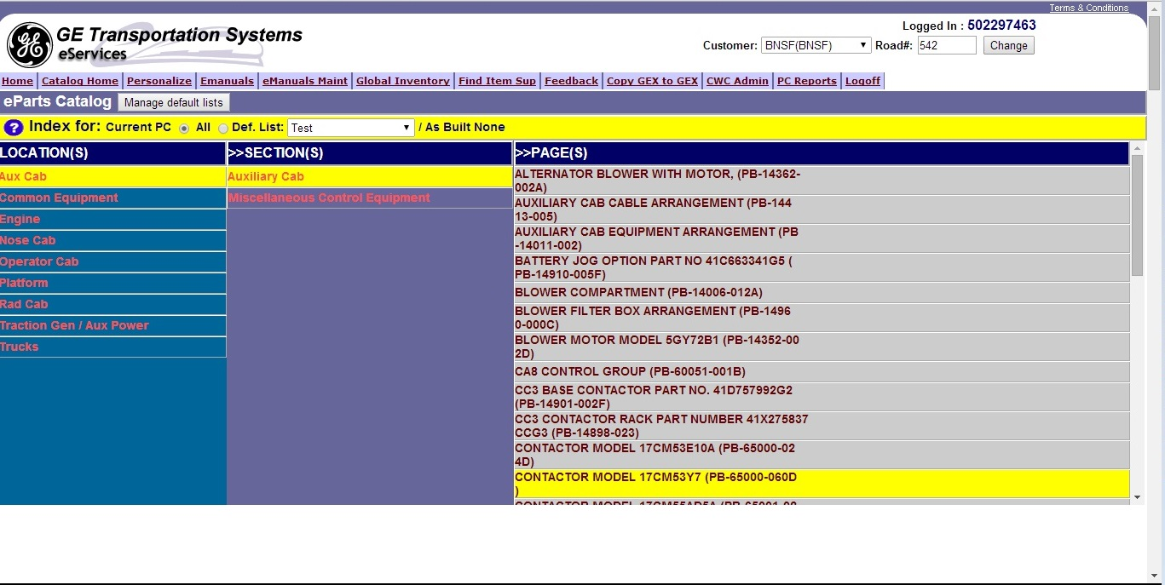

Clicking on a PB page (such as PB-14362-002A) will open another window and let you view the associated list of parts & any drawings that are tied to that PB.

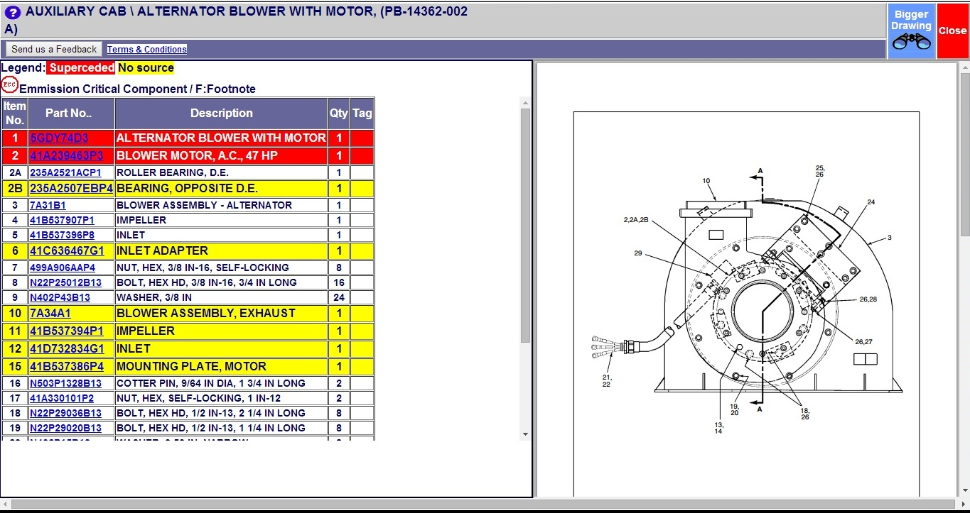

Clicking on a part (such as 5GDY74D3) will take you to a part information page for that part: 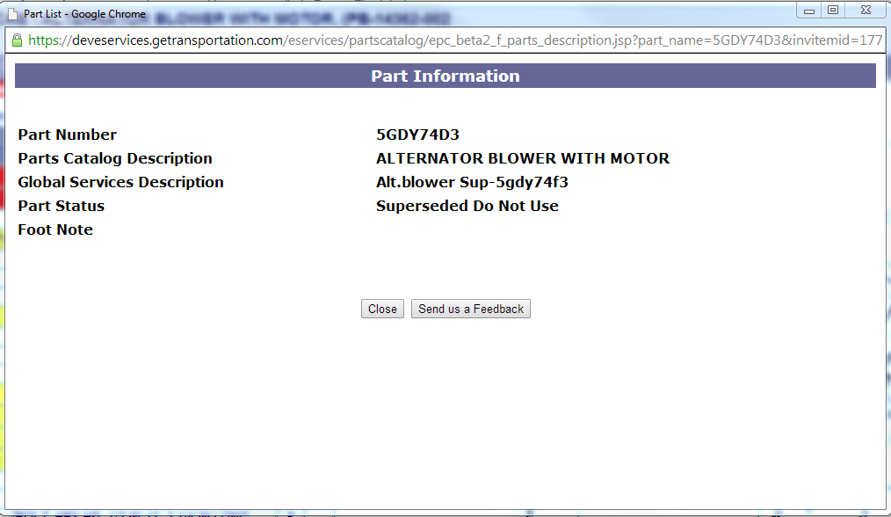

## Ordering Parts from eParts Catalog in eServices

When working with material requests in eServices you can, at the very least, order parts automatically when creating a new work-order, automatically when attaching a new service sheet to an existing work-order, manually from the shopping cart, from a repair kit in the shopping cart, and from the parts catalog in the shopping cart*.

*(The shopping cart, if you don’t know, can be accessed from the defects page by selecting request under the materials column. There are other ways to get to this screen, but as long as the shopping cart has the parts catalog link it doesn’t matter how it is accessed.)

When ordering parts through the parts catalog in the shopping cart you are taken to a version of the eParts Catalog. This version is almost exactly the same as the eServices Search version. The only differences is for the shopping cart version you can check box what parts you want to show up in the cart from the PB page:

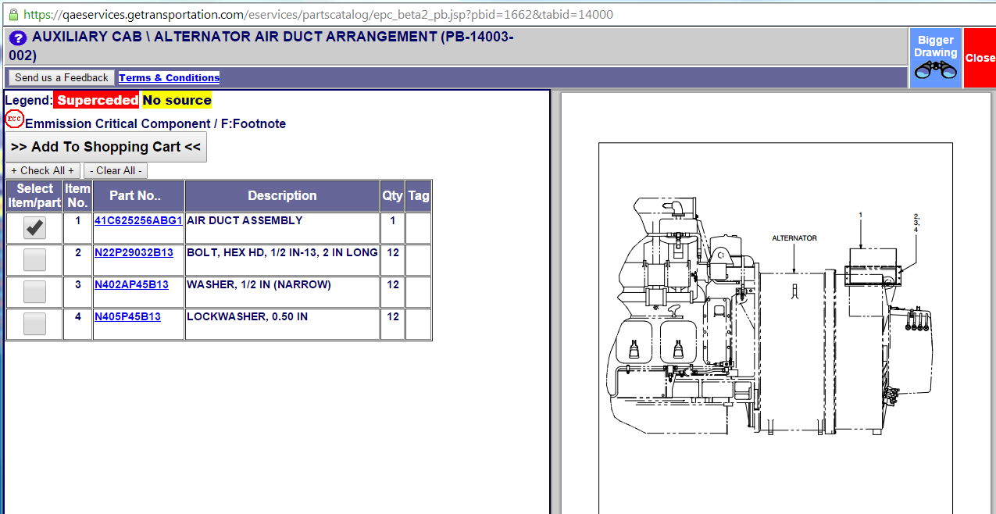

# Roles and Responsibilities

## Parts Catalog Administration roles

* **Documentation center:** This is the main responsibility that is related to parts catalog. Most of the creation & maintenance process can be managed through with this responsibility.
* **Material Planner Super User:** This responsibility has access to the Catalog Home like Documentation center, but only application it is used for is to approve or reject Parts Bulletins using the Edit PB screen.

## Responsibilities with access to view a parts catalog

Almost every responsibility within eServices has the ability to view a parts catalog using the Home Page Search for eParts Catalog.

## Responsibilities with access to order from parts catalog

Almost any responsibility that has access to sign off defects has access to order parts from parts catalog.

In addition many CWC users have access to view and order from parts catalogs for their respective customers.

## Other

* **eServices Read Only:** This is a responsibility that has a limited access to eServices. It has the Bulletin Transaction here. (The Bulletin Transaction is a querying tool for parts catalog)

# Other Common Questions about Parts catalog

## Where do the PDF drawings come from that are in the parts bulletins when a search is done from the home page?

The pdf drawings are created by documentation center and loaded into what they call the toaster 4 folder (might also have to do with drawing retrieval.) Specifically it is called \\dwgretdata\CATALOG and all of the PB drawings are stored here.

There are two types of PB drawings, the artwork drawing PDF and the documentation drawing PDF. The artwork drawing is the one we usually pull for the parts bulletin, but if one does not exist we will either pull the doc drawing, the No Art PDF, or nothing at all if setup isn’t done correctly.

When doc center creates the drawing PDFs they have a naming standard for the folders they drop them in within the toaster 4 folder. For the artwork drawings the folder will have an ‘A’ proceeding the acronym for the parts bulletin and a space dash followed then by the first two numbers in the main section of a parts bulletin. An example would be for PB-17860-002 the artwork folder would be named “APB_17.” The documentation drawing folder would drop the “A”. For the same example the doc drawing folder would be called “PB_17.”

When documentation center creates a new parts bulletin using the “New PB Name” screen it creates an arbitrary folder name. It then inserts that into the file path field within our GETS_PC_PB table for the artwork drawing. Older parts bulletins use the documentation drawing in the parts catalog search; doc drawing names and files paths are stored in separate fields.

After the file path is found it creates an arbitrary file name for that newly created PB. Arbitrary, because the file name is recorded in our database whether or not an actual file exists within the toaster 4 folder for that newly created parts bulletin. These arbitrary file paths and file names are then used later when the eParts catalog screen retrieves a PB. It will connect to that file, if one exists, using the file path provided in the PB table.

Examples of both Artwork drawing & Doc Drawings below:

 

## How does one know if a locomotive has a parts catalog?

When a locomotive is assigned a GEX a unique parts catalog id is created that directly ties the locomotive and the GEX together. This field is in the GETS_LMS_LOCOMOTIVE_ALL table. If PARTS_CATALOG_ID is not null, that locomotive has a parts catalog.

## What is the difference between Part Number on the GETS_LMS_LOCOMOTIVE_ALL table and Locolist Name on a Parts Catalog?

Part Number is a Locolist Number just like the Loco Name on a Parts Catalog. The Part number is assigned through the ERP using the Locomotives Tab in the GETS_LMS_ADMINISTRATOR resp. The Part Number is assigned by someone on the Material planning side of things when a Locomotive is in-serviced. The Locolist Name is assigned by the Documentation Center when they are creating the GEX Master.

Several Parts Catalogs on eServices have multiple Locolist Names, many of which are outdated and incorrect. Additionally, the GETS_LMS_LOCOMOTIVE_ALL parts number is also sometimes outdated/incorrect due to the manual process in which they are assigned.

However, the Part number field on the GETS_LMS_LOCOMOTIVE_ALL table is considered by many to be the more correct field to use when considering Locolist Numbers due to the nature of it having singular results when considering locomotives. Part Number is used by the ePC search on eServices, the CWC & the List Configurator Application as if it were the Locolist.

# Technical Details

## Database Tables (Including but not limited to)

**Locolist Related:**

GETS_PC_LOCOLIST

GETS_PC_LOCOLIST_X_CATALOG (Also related to GEX’s)

**GEX Related:**

GETS_PC_CATALOG

GETS_PC_COMPILE

**Parts Bulletin Related:**

GETS_PC_CATALOG_X_TAB_PB (Also related to GEX’s & Tabs)

GETS_PC_PB

GETS_PC_PB_X_ITEMS (Also related to parts)

**Standard List Related:**

GETS_PC_STD_LIST_X_PB (Also related to PB’s)

GETS_PC_STD_LIST

GETS_PC_STD_LIST_PARTS

**Parts Related:**

GETS_PC_ITEMS  
MTL_SYSTEM_ITEMS  
MTL_SYSTEM_ITEMS_VL

GETS_PC_CUST_PARTS  
GETS_PC_ARB_VEND_PART

MTL_ITEM_STATUS

**Section/Location/Tab Related:**

GETS_PC_LOCATION

GETS_PC_LOCATION_X_TAB  
GETS_PC_TAB_SECTION

**Other related Tables:**

AR_CUSTOMERS

GETS_LMS_LOCOMOTIVE_ALL

Refer to the PC ERD or the Parts Catalog Table Matrix for more information.

## Supporting Technical Documentation

 

# Appendix/Supporting Documentation

## Additional Documentation

 

## Definitions:

**As-Built** – As it was when manufactured

**As-is** – The most up-to-date configuration currently documented

**ARB** – Arbitrary Number, a part number used as a representation; may be assigned on a random basis just to have a number to tie to.

**CAS-RAIL** – An internal GET application, which we receive STD List data from. This is currently in the process of being converted to the Oracle ERP platform (as of Nov 2015)

**CWC** – Customer Web Center, another GET web application that uses parts catalog data

**Doc Center** – Can reference the employees of GE that create & maintain parts catalogs or is an abbreviation of the responsibility Documentation Center

**Drawing retrieval** – Another GE application that Doc Center uses in the GEX creation process

**DWG** – Drawing Number, comes after Loco-List, comes before standard list in the process diagram

**EPC** – Electronic Parts Catalog (eParts Catalog)

**GEX** – Parts Catalog, a bill of materials for a locomotive or M&SP engine; made up of several parts bulletins.

**List Configurator** – Another GE Application based around searching for consumable parts.

**LL** –Loco List, the list of specifications for a GEX and the part number for a road number, these come from Drawing Retrieval on a manual basis (no automated process, input manually on eServices)

**M&SP** – Marine & Stationary Power, often referring to GE business section that produces tugboat & generator engines.

**MP** – Material Planner

**OHV** – Off Highway Vehicle

**PB** – Parts Bulletin, a parts assembly list.

**PBA** – Parts Bulletin Amtrak, an assembly list used specifically for Amtrak.

**PC** – Another acronym for Parts Catalog

**PC Reports** – Parts catalog’s querying module, this was migrated from an older set of reports that were running in Microsoft Access off of the Database Warehouse tables

**RN** – Road number, often refers to locomotives

**SN** – Serial number, often refers to M&SP engines

**STD List** – Standard List, similar to a parts bulletin, comes from CAS-RAIL.

**TAB** – Index for parts bulletins

**VEND** – Supplier Part number, the name the supplier gives the part

**VEND CODE** – The ID for the specific supplier connected to the part

## Related Modules

**CWC** – Utilizes the parts catalog search from eServices & shares FAM’s, AESS and Manuals data with eServices. Customer Web Center is another GET web application for customers to lookup information related to their locomotives or engine, order parts, or run reports. CWC is heavily used by Marine & Stationary Power customers & the related GE users.

**List Config** – uses a lot of the same tables that eServices does for parts catalog.

**Manuals** – these are also maintained by the Doc center team and its main responsibility is Documentation Center, also in eServices Search. Manuals show how to maintain a locomotive by providing directions for servicing.

**Transactions/reporting** – Parts catalog has the Bulletin Transaction found in eServices Read Only. In addition Parts catalog has its own reporting tab in Documentation Center.

**Schematics** – Can also be found in the eServices Search. Schematics are the configuration drawings produced by engineering.

**Materials** - This is related as a user can request material from the parts catalog of a locomotive through the shopping cart screen.

## Contact Information

Analyst: Thomas Johns

Email: thomas.johns@ge.com

Phone: 1-814-240-2700

Location: Knowledge Park – Erie